1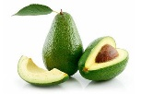

Avocados

2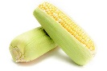

Sweet Corn*

3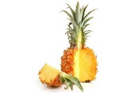

Pineapples

4

Cabbage

5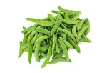

Sweet peas frozen

6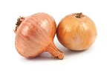

Onions

7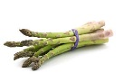

Asparagus

8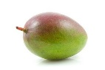

Mangos

9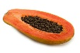

Papayas*

10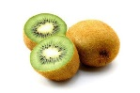

Kiwi

11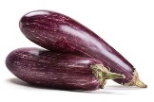

Eggplant

12

Grapefruit

13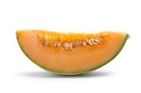

Cantaloupe

14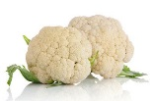

Cauliflower

15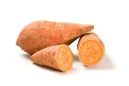

Sweet potatoes
* A small amount of sweet corn, papaya and summer squash sold in the United States is produced from GE seedstock. Buy organic varieties of these crops if you want to avoid GE produce.

Consider buying these produce at the regular counter and the “dirty dozen” labeled as organic to cut down on your grocery bill and yet lower the amount of pesticide in your family’s fruits and vegetables.

