1

Apples

2

Peaches

3

Nectarines

4

Strawberries

5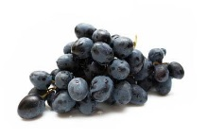

Grapes

6

Celery

7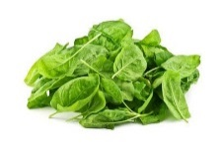

Spinach

8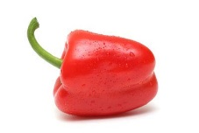

Sweet bell peppers

9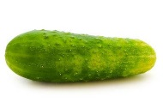

Cucumbers

10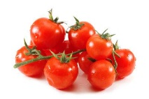

Cherry tomatoes

11

Snap peas - imported

12

Potatoes

+

Hot Peppers +

+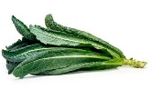

Kale / Collard greens +

Key findings:
- 99 percent of apple samples, 98 percent of peaches, and 97 percent of nectarines tested positive for at least one pesticide residue.
- The average potato had more pesticides by weight than any other produce.
- A single grape sample and a sweet bell pepper sample contained 15 pesticides.
- Single samples of cherry tomatoes, nectarines, peaches, imported snap peas and strawberries showed 13 different pesticides apiece.

Consider buying these produce as “organic” and the “clean fifteen” at the regular counter to cut down on your grocery bill and yet lower the amount of pesticide in your family’s fruits and vegetables.

