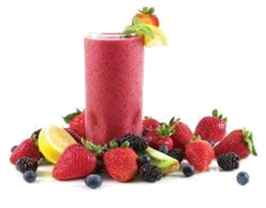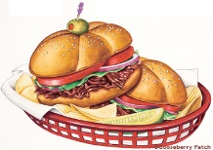DIRECTIONS: In order to analyze your child’s nutrition intake, we need the following information. Please record everything your child eats or drinks over a three-day time period, the time of the meal or snack, and the exact portion. (Note proportion guidelines below.) One record sheet for each day. The more specific the information regarding brand names of food items or restaurant meals, the more accurate the computer analysis will be.
*PEDS, Inc. does not endorse the listed examples to be used as a dietary recommendation. These are mere examples of what information needs to be recorded to ensure an accurate analysis.

Name: Date:
TIME | SOLID FOOD: brand, method of preparation, etc. | AMOUNT: cup, tsp, tbsp., oz., slice, lbs., etc. | BEVERAGE: brand, flavor, etc. | AMOUNT: fl. oz., cup, pouch, box, etc.
EXAMPLE:
6:30am | Cheerio’s  Scrambled Eggs (used water) | 1 cup  2 eggs  1tsp salt | Tropicana Orange Juice, no pulp  2% Milk | 1 cup  1/2 cup
10:30am | Snack Mix Cheez Its | 10.5 oz. bag | Dr. Pepper Soda | 12 fl. oz.
3:30pm | McDonald’s Cheeseburger  McDonald’s French Fries | 2  1 large | Dr. Pepper Soda | Medium size
7:30 pm | Tombstone Pepperoni Pizza—thin crust  Mixed Green Salad with cheese  Wishbone Italian Dressing  Kraft’s Shredded Cheese | 1 slice from 6 slice pizza  ¾ cup chopped iceberg  1 tbsp. chopped red cabbage  ½ tsp reduced Kraft cheddar cheese  ¼ cup diced tomatoes  1 tbsp. chopped onions  2 tbsp. dressing | Skim Milk | 1 cup
HELPFUL HINTS!
Whole Thumb= 1 tbsp.  Palm of hand/deck of cards= 3 – 4 oz.  Fist= 1 cup  Handful= 1 cup | 1 egg= 1 oz. lean meat  1 slice bread= 1 serving  1 apple= 1 serving  ½ cup cooked cereal/pasta= 1 serving | ½ cup cooked vegetable= 1 serving  ½ cup fresh fruit= 1 serving  1 cup milk= 1 serving

